
ASESMEN SUMATIF AKHIR SEMESTER 1
TINGKAT SMP KABUPATEN / KOTA
TAHUN PELAJARAN 20../20..

LEMBAR SOAL KURIKULUM MERDEKA

Mata Pelajaran : Bahasa Inggris
Satuan Pendidikan : SMP ………………
Hari dan Tanggal :
Waktu :
Kelas : VIII (DELAPAN)

PETUNJUK UMUM:
- Tulislah nama dan nomor pada lembar jawab!
- Bacalah tiap-tiap soal dengan sebaik-baiknya!
- Kerjakan lebih dahulu soal yang kamu anggap paling mudah!
- Periksalah kembali pekerjaanmu sebelum kamu serahkan kepada bapak/ibu guru!
PETUNJUK KHUSUS :
- Chosse the correct answer by crossing (x) a, b, c, or d!

Read the text below to answer questions 1,2 and 3!

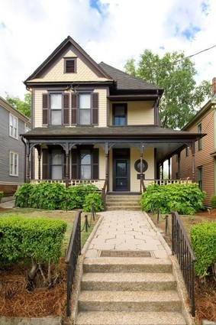
My Holiday at home

In the morning, I woke up and (1)
…….breakfast. After that, I played with my cat. In the afternoon, I had lunch and after that I
(2)... a nap. In the evening. I (3). until I felt
bored.

- ​
  - Had
  - Have
  - Has
  - has got
- ​
  - take
  - taken
  - took
  - has taken

- A. watch
B. watched
C. watching
D. has watching

Read the text below to answer the text number 4 and 5!
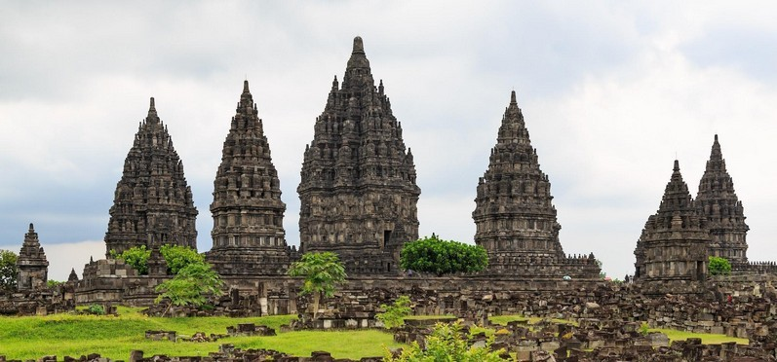
My holiday to Prambanan

Last holiday my students and I went to Jogjakarta. We stayed at Morison Hotel which is not a long way from Malioboro. On Friday, we went to the sanctuaries in Prambanan. There are three major sanctuaries, the Brahmana, Siwa, and Wisnu sanctuaries. They are truly stunning. We went by just Brahmana and Syiwa sanctuaries, on the grounds that Wisnu sanctuary is being remodeled. On Saturday morning we went to Jogja Kraton. We spent around two hours there. We were fortunate on the grounds that we were driven by a brilliant and amicable aide. At that point we proceeded with our adventure to Borobudur. We touched base there at four p.m. At 6 p.m. we heard the declaration that Borobudur entryway would be closed. In the evening we left Yogyakarta by bus.

- The content above basically talks about ……..
  - the writer’s trip to Yogyakarta
  - the writer’s first visit to Prambanan
  - the writer’s impression about the guide
  - the writer’s experience at Yogya Kraton

- Why did they just visit Brahmana and Syiwa sanctuaries?
  - because there was no wisnu temple
  - because wisnu temple was amazing
  - because wisnu temple was too small
  - because wisnu temple was being repaired

Read the text below to answer the questions number 6,7, and 8!

Last week I went to see a waterfall with five of my classmates. We went there early in the morning by bus. At 5.30 a.m. all of us had gathered at the bus stop waiting for the bus that would take us to our destination. Only ten minutes later the bus came and it was almost fully seated since it was a holiday. Luckily, we all got seats.
During our journey, we enjoyed enchanting scenery. Many big trees grew on the left and right sides of the road, everything looked so green and fresh. The weather looked so fine. We could clearly see the green hills and the sun which was coming out behind the hills.
Two hours later, the journey ended. My friends and I got out of the bus and walked to the waterfall resort. It took fifteen minutes to reach the resort. To see the waterfall, all visitors had to walk through many stone steps which were quite slippery because it had rained last night.
Arriving down, we saw a beautiful waterfall flowing down. The water was so clear and fresh. We splashed around and surely we got wet.
6. What is the text mainly about?
- tell about something in general
- describing the beauty of waterfall
- showing how to get the waterfall
- tell about the experience visited waterfall

- What is the main idea of paragraph 2?
  - The journey to the waterfall
  - The scenery along the journey
  - About the weather of the day
  - The trees growing on each side of the road

- Why were the steps to the waterfall slippery?
  - Because there were many steps
  - Because of the rain last night
  - Because many people walk through them
  - Because of water splashing from the waterfall

Read the text below to answer questions 9 and 10!

Last holiday, my family and I decided to spend our time in a village which is famous for their wooden crafts. We had planned this for a month because we just moved to a new house and wanted to look for new home decorations. We left early since we wanted to visit our relatives after the visit.
At the village, we were amazed by the diversity of the crafts we saw. We could find small toys, unique boxes and furniture. Several shops also offered a quick lesson on crafting. I had a chance to learn how to make a simple wooden craft in a workshop. In the meantime, my family went to look for several crafts to decorate our house. We spent quite some time in the village.
Satisfied with my lesson in the workshop, I decided to find the others. However, I couldn't find them. Then, I decided to go to the parking lot. To my surprise, I saw my car moving slowly from its place. I yelled and waved while chasing the car. The car stopped and someone I didn’t know came out. Then, I heard someone calling me from the parking lot. That was my family. I felt embarrassed and then apologized to the people in the car that I had chased.

- What is the main idea of paragraph two?
  - Various crafts are made by the village people.
  - The writer’s family bought crafts from the village.
  - The writer’ and his family decided to go to a village
  - The writer and his family did different activities in the village.

- Why did the writer decide to go to the parking lot?
  - He wanted to look for his car.
  - He thought he would find his family there.
  - He needed to rest after his crafting lesson.
  - He supposed to wait for the others there

The following text is for questions 11 to 12.

Lita : How are you, Suma?
Suma : I am fine, Lita. What about you?
Lita : I am fine too. So school has started again and how was your holiday? Suma : My holiday was amazing. I (11)... for a family picnic and visited a few of my relatives.
Lita : That seems interesting. Where did you go for the picnic?
Suma : We went to Rajasthan. We stayed there for three days in a resort. We
(12)... a night camping near a desert.

- The correct word to fill in the blank is ….

  - went
  - gone
  - going
  - go

- The correct word to fill in the blank is …

  - spending
  - was spent
  - spend
  - spent

The following text is for questions 13 to 15.

I just returned from my holiday to my uncle’s house in Malang. During that time, I visited many interesting places, such as Jatim Park 1 and 2, Museum Angkut, Batu Night Spectacular and Mount Bromo. However, the most memorable is my trip to Mount Bromo. It is the most exotic place I’ve ever seen.
At that time, I went with my uncle’s family. We went there by car in the middle of night and arrived at around 3:30 a.m. There were already many people there. They all wore thick jackets, gloves and beanies, so did we. It was so cold that we were going to freeze. Soon, we could adapt to the weather.
Later on we moved to Penanjakan Peak to see the sunrise. We witnessed such a magnificent sunrise. Luckily, the weather was so fine that we all could see that shining golden ball very clearly. Then, we walked up to the top of Mount Bromo. It was really hard because we had to walk through thick sand desert while it was rather cold. Arriving at the top, it was so amazing! Trust me, you should go there one day. What a wonderful place!
Overall my last holiday was the best moment of my life. I wish I had another chance to explore Malang City.
- “We went there by car in the middle of night and arrived at around 3:30 a.m.” (Paragraph 2). How long did the writer take time to reach Mount Bromo?
  - Three hours
  - Three and a half hours
  - Four Hours
  - Four and a half hours

- “They all wore thick jackets, gloves and beanies, so did we.” ( Paragraph 2 ) What does the bolded word refer to?
  - The writer’s uncle family
  - The visitors of Mount Bromo
  - The writer and her uncle’s family
  - The people who the writer saw on her arrival

- “It was really hard because we had to walk through thick sand desert while it was rather cold” (Paragraph 3). What is the antonym of the word “thick”?
  - Thin
  - Bold
  - Dense
  - Hard

The following text is for questions 16 to 20.

One holiday, Vandra visited his uncle in a village. It was his first experience of traveling by train, but he enjoyed it. He arrived at the railway station at 3 p.m. His uncle’s house was not far from the railway station, so he decided to go there by horse cart.
Vandra stopped a horse cart. To his surprise, the rider was a woman. She was dark skinned and looked strong. Along the journey, they had a chit-chat. The rider told him about her life. She was a wife with three children. She was simple, but had a great dream. She wanted her children to be successful. As a mother, she was willing to work hard for her children’s education. She never gave up. She believed that her hard work would be paid-off.
Vandra was amazed at the horse cart rider’s story. What a great woman.

- The text is written to….
  - describe Vandra’s horse cart
  - explain the rider’s inspiring life
  - portray the railway station in Vandra’s village
  - tell the readers about Vandra’s past experience
- What is the second paragraph about?
  - The situation of Vandra’s village
  - The life story of a horse cart rider
  - Vandra’s traveling experience
  - Vandra’s experience on a train
- How did Vandra go to his uncle’s house from the railway station?
  - On foot
  - By car
  - By horse cart
  - By mini bus
- “She was dark skinned and looked strong.” (Paragraph 2). What does the word “she” refer to?
  - Vandra
  - The horse cart rider
  - The rider’s daughter
  - Vandra’s mother

The text is for number 20-22

It was early in the morning we left Ubud and traveled to Gili Air which is one of three islands of Lombok. It took 4 hours in total by boat. The traveling was not bad but it was a hot day. I said to Jane on the slow boat " It's alright babe, it won't be so hot and stuffy once we get moving.”
When we got to Gili Air it was still quiet so we were able to get a bungalow near the beach for about $ 15 a night plus breakfast. We shared our room with quite a number of geckos. Some of them were quite large ones.
The weather was still hot when I went diving. Jane waited for me at the seashore. She observed some fishermen who had just caught some fish. She did not want to dive because she had a trauma with sea animals. We had three days here which we spent walking around the island which takes about an hour. Every night, we sat on the couches near the beach and watched the waves and the stars.
It was a fantastic journey that I ever had.

- “The traveling was not bad but it was a hot day.”(paragraph 1) What is the opposite of the word “ hot”?
  - Cool
  - Warm
  - Calm
  - Bright

- ” Every night, we sat on the couches near the beach and watched the waves and the stars.” (paragraph 3)
The antonym of the underlined word is …
  - Far
  - Close
  - Beside
  - around

- “ It was a fantastic journey that I ever had.” (last paragraph) The word “ fantastic” has the opposite meaning to …
  - Exotic
  - Ordinary
  - Enormous
  - wonderful

The text is for number 23-25
Last year I joined the Chicago Marathon, my first marathon contest. I had to run 26,2 miles to complete it. It was hard.
At first, I just wanted to get the experience of joining a marathon. I thought it would be one life time experience.After finishing it, I changed my mind.I wanted to join another one. I was interested to complete at least one more marathon and improve my time. I also experienced a good feeling between participants and the spectators that made me happy. It was a very wonderful thing for me. So I decided that I had to join another marathon the following year.
- “ Last year I joined the Chicago Marathon, my first marathon contest.” (paragraph 1)
The underlined word has the same meaning as ...
  - joined
  - Follow
  - Competition
  - cooperation
- “... I change my mind.” (paragraph 2) the word “mind” is closest in meaning to ...
  - thought
  - Decision
  - Ambition
  - Suggestion
- “ So I decided that I had to join another marathon the following year”(paragraph 2)
What is the synonym of the word “ decided “?
  - Indistinct
  - Determine
  - Suggestion
  - Uncertain

The text is for number 26-27.
Last summer, I got a fantastic holiday. I first flew to cleveland. I spent two days there.I watched Cleveland Cavaliers basketball matches. Then, I went to Hollywood, a district in Los Angeles, California. It had been so well-known as the center of American's film industry, Four major film companies-Paramount, Warner Bros, RKO, and Colombia-had studios in the district. From here, I went to New York city. I visited the statue of Liberty. I went from the bottom of Manhattan to the crown. That was so amazing. The place made me feel at home but I have to go home.

- “ I spent two days there.”
What does the underlined word refer to ?
  - His friend
  - The writer
  - His father
  - His brother
- “ It had been so well-known as the center of American’s film industry” What does the underlined word refer to?
  - Los Angeles
  - California
  - Cleveland
  - Hollywood

The text is for number 28-30
Last Friday, my friend asked me to accompany him to buy a new shirt at a department store. We left home at 03..00 p.m. by motorcycle. As soon as we arrived there, we went to the clothes section. I let him choose one. An hour later, I got bored watching him confused in choosing a shirt. So I left him and went to the cassette counter. Thirty minutes later, I went back but I couldn’t find him there. My cell phone was broken so I couldn’t call him. I went to the parking area. I saw his motorcycle was there but I couldn’t find him. I waited for him for a few moments then finally I gave up and decided to go home.
When I arrived home, My mother told me that my friend called. She said that he was in the department store looking for me. My mother asked me to come back to the department store. I walked to the department store. When I arrived there his motorcycle was not in the parking area.He just went home. I was very tired. There was no other choice, I had to walk home again. When I arrived home, I was so tired. I was very angry but when I saw my friend’s broad smile greet me in front of the door, I just could not help laughing.
- The text above is about ...
  - an embarrassing day
  - shopping with mother
  - the writer and his friend
  - my friend and his motorcycle
- The writer couldn’t contact his friend because ...
  - he went home alone
  - cell phone was broken
  - he was in the parking area
  - his friend was still choosing a shirt
- From the text above we can conclude that there was a problem because ...
  - the writer couldn’t contact his friend
  - the writer’s friend was in the clothes section
  - the writer and his friend couldn’t ride the motorcycle
  - the writer and his friend decided to go to the department store

The following text is for question 31 to 32.

“Feby, I really sorry I cannot join you and Sekar to visit the new bookstore as we have planned this morning. I sprained my ankle. I’d better have a rest at home.”
From : Vandra

- What is the message about?
  - Arranging a plan.
  - Having an accident.
  - Visiting a bookstore.
  - Cancelling an appointment.

- What is Vandra doing that afternoon?
  - Meeting Sekar
  - Calling Feby
  - Staying at home
  - Visiting the bookstore

The following text is for question 33.
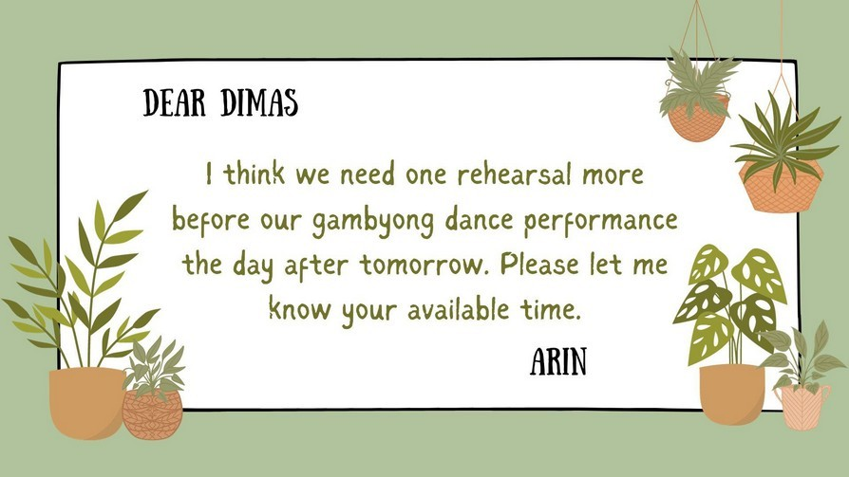
- The text is mainly about …. the available time to practice a gambyong dance.
  - asking for
  - reminding
  - stating
  - announcing

- What would happen if the receiver texts the available time?
  - The rehearsal schedule is set.
  - The dance show is postponed.
  - The performance is done
  - The rehearsal is cancelled.

The following text is for question 35 to 37.
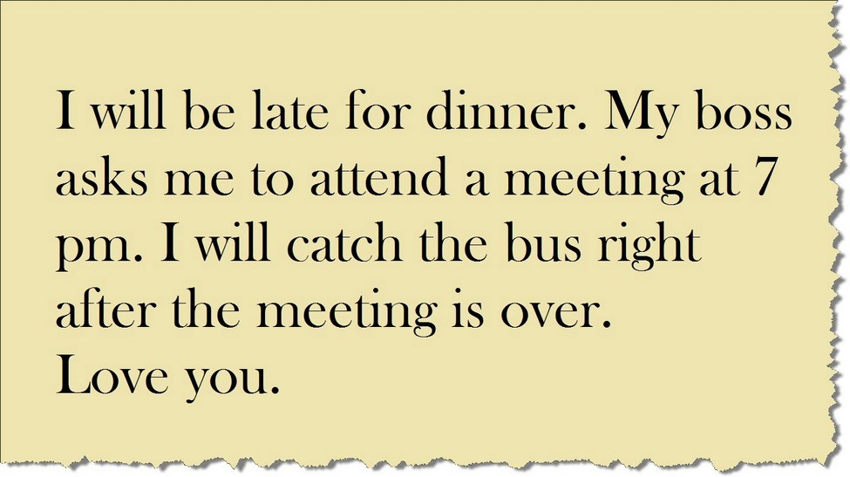
- Why is the writer late?
  - He is sick
  - He attends a meeting
  - He already ate dinner
  - He has a party to attend

- How will the writer go home?
  - He will walk
  - He will take a taxi
  - He will ride a car
  - He will take a bus

- When will the meeting begin?
  - At 7 pm
  - At 7 am
  - At 6.30 pm
  - At 8 am
The following text is for question 38 to 40.
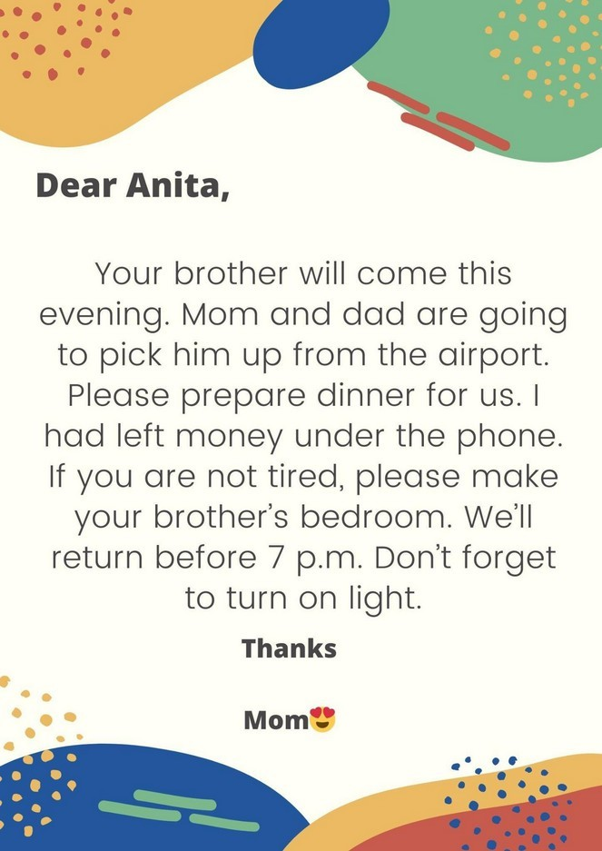

- Your brother will come this evening.
The opposite of the underlined word is………
a.Go c. Busy
b.Buy d. Welcome

- If you are not tired, please make your brother’s bedroom.
The close meaning of the italic word is…….
a. Weak c. Weary
b. Strong d. Sleepy

- If you are not tired, please make your brother’s bedroom
The underlined word means……..
a. Sweep c. Tidy up
b. Entered d. Open

Read the texts below to answer questions 41 and 43!
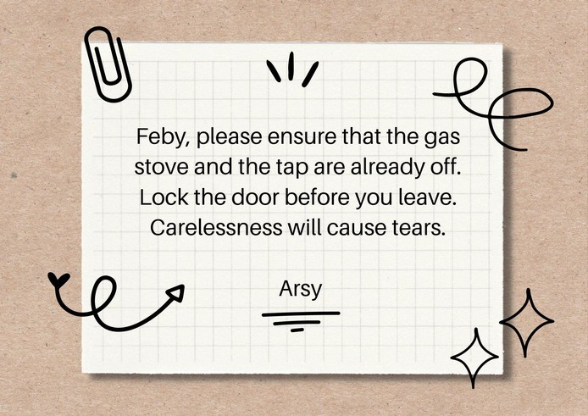

- What should Feby do after reading the message?
  - Use the stove
  - Leave the house.
  - Turn off the water tap.
  - Unlock the front door.

- What can we conclude from the text?
  - Do everything carelessly.
  - Use a spare key to lock the house.
  - Never use a gas stove unattended.
  - Leave the house in a safe condition.

- “Lock the door before you leave”. The word you refers to …
  - Arsy
  - Feby
  - Arsy’s mother
  - Feby’s mother

Read the texts below to answer questions 44 and 46!

Dear Suci,
Tomorrow is a holiday. If you are free, what about spending your holiday in my house? You are fond of eating fish, aren’t you? My family and I will catch fish in my pond and grill them. Please join us.

Dimas

- What should Suci do right after reading the message?
  - Go to Dimas’s house.
  - Catch the fish in the pond.
  - Confirm whether she will come or not.
  - Join the barbecue party at Dimas’s house.

- From the text we know that…..
  - Suci has a pond
  - Suci dislikes fish
  - Suci will grill fish
  - Dimas knows Suci’s favorite

- “Please join us”. The word us refers to …

  - Suci’s family
  - Dimas and Suci
  - Dimas’s family
  - Suci and Dimas’s family

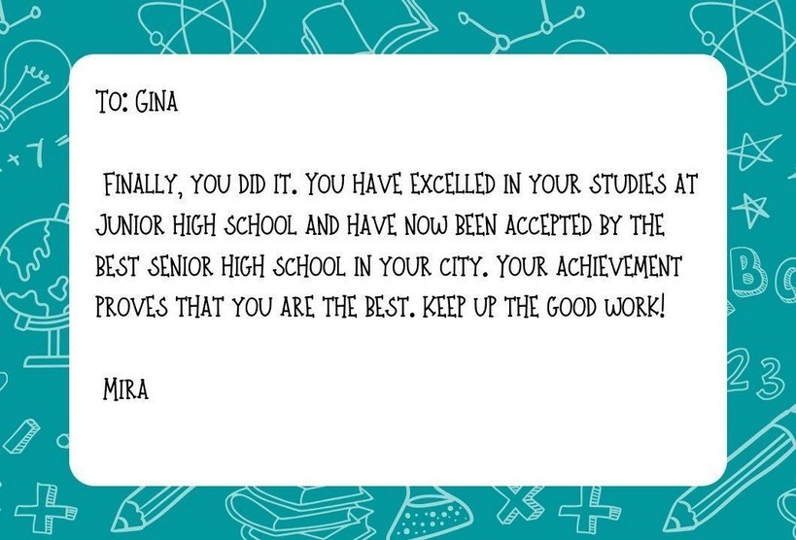
Read the texts below to answer questions 47 and 48!
- From the text we know that ….
  - Gina is the best student in her city
  - Gina did not pass the examination
  - Gina will study at the best senior high school
  - Mira asks Gina to enroll at the senior high school

- Which of the following is true? 50
  - Mira passed the final exam
  - Gina didn’t pass the final exam
  - Gina has been accepted in the best senior high school
  - Mira has been accepted in the best senior high school

Read the texts below to answer questions 49 and 50!
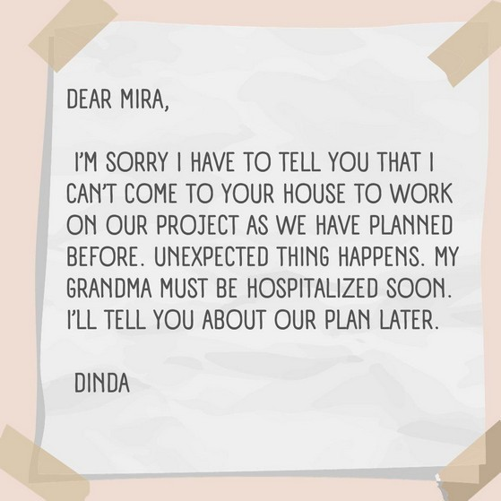

- What did Dinda’s purpose to write such kind of message? 46
  - To tell about her sick grandma
  - To ask Mira to work on their project
  - To persuade Mira to change the project
  - To give information about the delay of an activity

- …. as we have planned before. The word “we” refers to…43
  - Mira and Dinda
  - Mira and her mother
  - Dinda and her mother
  - Dinda and her grandmother

KUNCI JAWABAN

1 | A | 11 | A | 21 | A | 31 | D | 41 | C
2 | C | 12 | D | 22 | B | 32 | D | 42 | D
3 | B | 13 | B | 23 | C | 33 | A | 43 | B
4 | A | 14 | C | 24 | A | 34 | B | 44 | C
5 | D | 15 | A | 25 | B | 35 | B | 45 | D
6 | D | 16 | D | 26 | B | 36 | D | 46 | C
7 | B | 17 | B | 27 | D | 37 | A | 47 | C
8 | B | 18 | C | 28 | C | 38 | A | 48 | C
9 | A | 19 | B | 29 | B | 39 | C | 49 | D
10 | B | 20 | A | 30 | A | 40 | C | 50 | A

